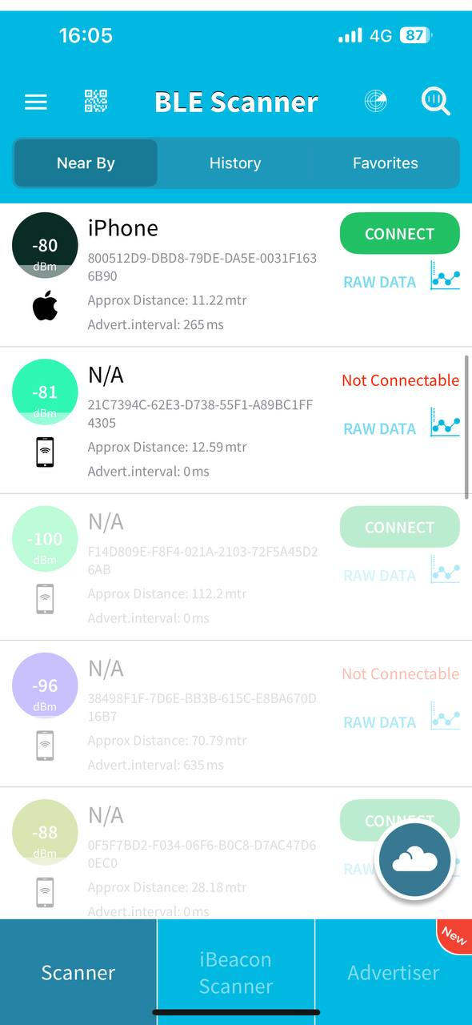
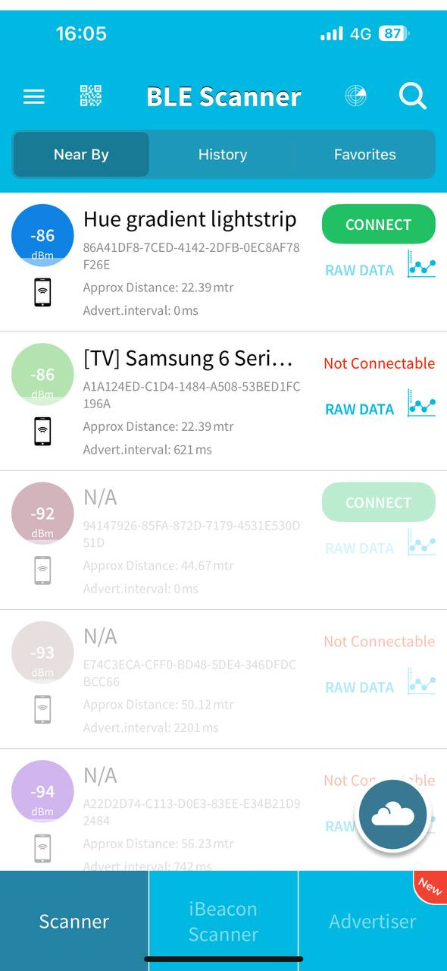
This screen i made at my home and second screen was made at outdoor area

BLE Device Analysis – Wireless and Radiotechnology Course 2026
Objective
The objective of this experiment was to investigate nearby Bluetooth Low Energy (BLE) devices and analyze their signal characteristics in different environments.
Tool Used
- BLE Scanner mobile application
Scan Environment
- Indoor environment (classroom / public indoor area)
- Smartphone connected to mobile network (4G)
Detected BLE Devices (Sample)
Device Name | RSSI (dBm) | Approx. Distance | Connectable
iPhone | −80 dBm | ~11 m | Yes
Hue gradient lightstrip | −86 dBm | ~22 m | Yes
Samsung TV | −86 dBm | ~22 m | No
Unknown device | −92 dBm | ~45 m | Yes
Unknown device | −96 dBm | ~70 m | No
Unknown device | −100 dBm | >100 m | Yes
Each device was identified by a unique MAC address or identifier provided by the scanner.
Analysis
- RSSI vs Distance:
Devices with stronger RSSI values (−80 to −86 dBm) were estimated to be closer, while weaker signals (−96 to −100 dBm) indicated greater distance.
- Environment Impact:
Indoor obstacles such as walls and furniture reduced signal strength and increased RSSI fluctuations.
- Device Types:
Detected devices included smartphones, smart lighting (IoT), TVs, and unidentified BLE devices, showing common everyday BLE usage.
- Anomalies:
Estimated distances are approximate and sometimes inconsistent due to reflections, multipath propagation, and varying transmission power.
Security and Privacy Considerations
- BLE is widely used in wearables, smart home devices, and beacons.
- Constant broadcasting allows passive device tracking.
- Device identifiers and names may expose user information.
- Open BLE advertising can be exploited for profiling and location tracking.
Conclusion
This experiment demonstrated how BLE devices are easily detectable in everyday environments and how RSSI can be used to estimate distance, though with limited accuracy. Environmental factors and device transmission power significantly affect measurements. BLE provides convenience and low energy consumption but also raises important security and privacy concerns.

